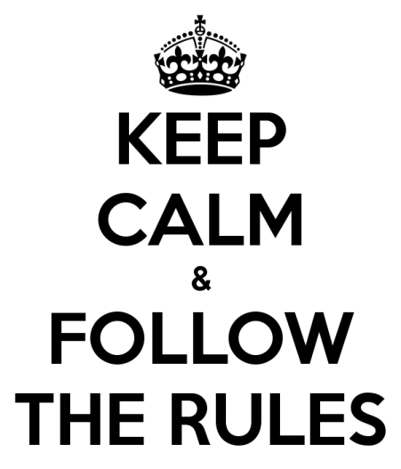
Expectations for Student Conduct
- Be Responsible.
- Be Respectful.
- Be Safe.

Be Responsible:
- Homework is completed.
- Forms are signed and returned.
- Agenda is signed.
- Students attend class with necessary supplies.
- Student work areas are neat and orderly.
- Students arrive in appropriate attire according to the established dress code.
Be Respectful:
- Students refrain from inappropriate language and gestures.
- Students are respectful to adults.
- Students are respectful for classmates.
- Students properly care for teacher and school property.
- Students respect the property of other students.
Be Safe:
- Students follow directions.
- Students remain in their seats as instructed.
- Students abide by expectations for hallway behavior.
- Students abide by expectations for classroom behavior.
- Students show respect for restroom facilities and expected restroom behavior.
- Students do not disrupt the environment with excessive talking when it distracts from the ability to hear and follow directions.
- Students abide by expectations for cafeteria behavior.

